Command Pattern Example: switch

Class Diagram:

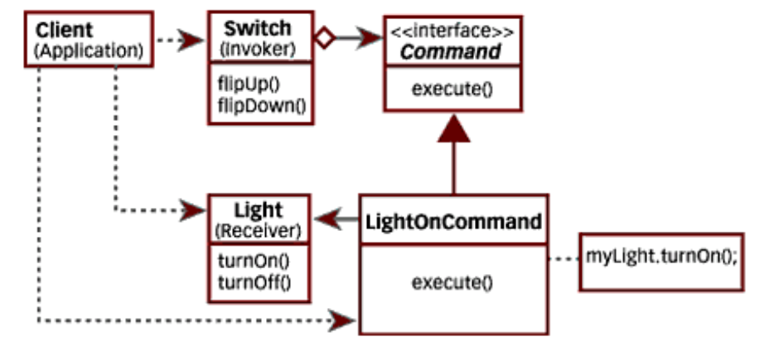
Sequence Diagram:
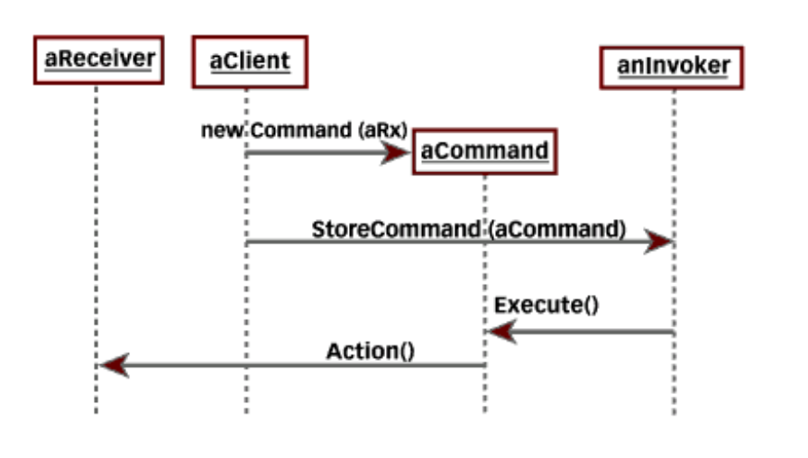

Reference: JavaWorld; Java Tip 68: Learn how to implement the Command pattern in Java, By Bala Paranj
http://www.javaworld.com/javaworld/javatips/jw-javatip68.html

class Fan {
public void startRotate() {
System.out.println("Fan is rotating");
}
public void stopRotate() {
System.out.println("Fan is not rotating");
}
}

class Light {

public void turnOn( ) {
System.out.println("Light is on ");
}
public void turnOff( ) {
System.out.println("Light is off");
}
}

class Switch {
private Command UpCommand, DownCommand;

public Switch( Command Up, Command Down) {
// concrete Command registers itself with the invoker
UpCommand = Up;
DownCommand = Down;
}
void flipUp( ) {
// invoker calls back concrete Command,
// which executes the Command on the receiver
UpCommand . execute ( ) ;
}
void flipDown( ) {
DownCommand . execute ( );
}
}

public interface Command {
public abstract void execute ( );
}

class LightOnCommand implements Command {

private Light myLight;

public LightOnCommand ( Light L) {
myLight = L;
}
public void execute( ) {
myLight . turnOn( );
}
}

class LightOffCommand implements Command {

private Light myLight;

public LightOffCommand ( Light L) {
myLight = L;
}
public void execute( ) {
myLight . turnOff( );
}
}

class FanOnCommand implements Command {

private Fan myFan;

public FanOnCommand ( Fan F) {
myFan = F;
}
public void execute( ) {
myFan . startRotate( );
}

}

class FanOffCommand implements Command {

private Fan myFan;

public FanOffCommand ( Fan F) {
myFan = F;
}
public void execute( ) {
myFan . stopRotate( );
}
}

public class TestCommand {
public static void main(String[] args) {
Light testLight = new Light( );

LightOnCommand testLOC =
new LightOnCommand(testLight);
LightOffCommand testLFC =
new LightOffCommand(testLight);

Switch testSwitch =
new Switch( testLOC,testLFC);

testSwitch.flipUp( );
testSwitch.flipDown( );

Fan testFan = new Fan( );
FanOnCommand foc = new FanOnCommand(testFan);
FanOffCommand ffc = new FanOffCommand(testFan);

Switch ts = new Switch( foc,ffc);

ts.flipUp( );
ts.flipDown( );
}
}

ref: http://www.javaworld.com/javaworld/javatips/jw-javatip68.html

Notes:
- Others use this same example for the bridge pattern(!); in that one can change back-end implementations (devices), and the front-end (switch) doesn’t know.

